8th Annual
JORDAN DRIGGERS
HOOK A CURE FISHING TOURNAMENT
Benefiting

The Cystic Fibrosis Foundation

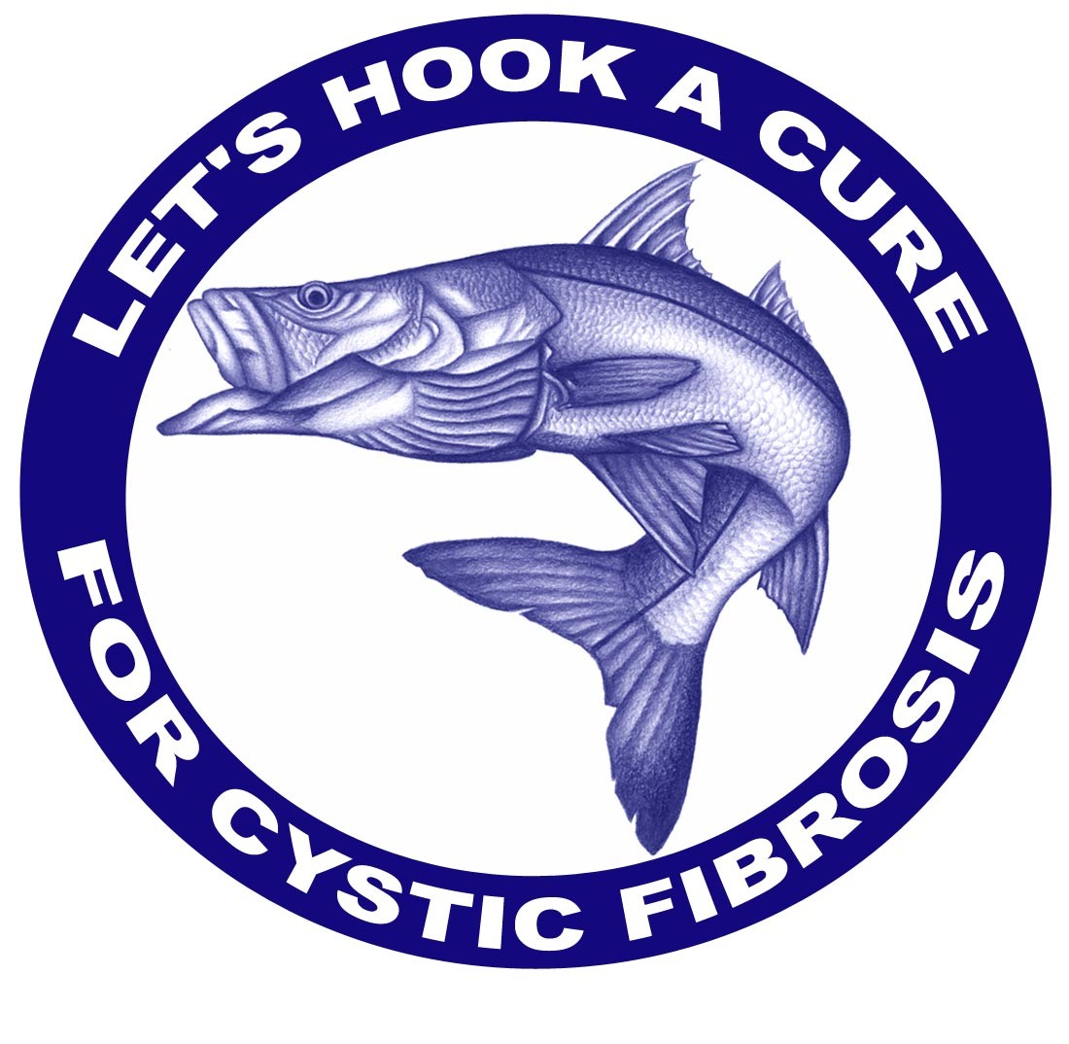
Sponsored by:


October 6 & 7, 2011
Ozona Blue Grilling Company &
HOMEPORT MARINA

WWW.HOOKACURE.COM

Event Overview
2011

Who: Anyone who loves the sport of fishing (or loves someone who does)

What: Join local anglers for a photo catch and release fishing tournament targeting redfish, trout and snook. Prizes are awarded for both guided and unguided divisions.

Where: Ozona Blue Grilling Company & Homeport Marina
125 Orange Street, Palm Harbor 34683

When: Captain’s Party
October 6, 2011 (Thursday)
Ozona Blue Grilling Company
5:30 pm - 9:00 pm
Includes dinner and drinks, silent and live auction and angler registration.

Fishing

October 7, 2011 (Friday)

Morning Check-in – not required
3:00 pm - All anglers must be in line with photos of their catch to be eligible to win.
3:30 pm - Awards presentation at Ozona Blue Grilling Co.

Why: To raise money for research necessary to find a cure for cystic fibrosis.

Registration: Professionally Guided Boat - $1500
(max. 3 amateur anglers)

Individual Anglers - $100

Register on-line at www.hookacure.com
Or Contact Wayne Driggers for more information
Phone: (727) 571-1313 or email: wdriggers@driggers-eng.com

JORDAN PAIGE DRIGGERS – 9 YEARS OLD



Jordan is our 9-year-old little girl. She was diagnosed with cystic fibrosis (CF) when she was just 2 months old. You would never know by talking to her or looking at her that she has this terrible disease. She runs, plays, talks and acts like any other child her age. However, the deterioration that is going on inside her, particularly in her lungs, is slowly eroding away at her health. Although most people and even Jordan, are virtually unaware of the destruction going on inside her body – her family and those close to her are definitely aware.

There is reason to be hopeful though. In recent years, significant gains have been made in the treatments and therapies for CF due primarily to fundraising projects such as the Hook A Cure Fishing Tournament. However, even though tremendous strides have been made, there is still no cure and the median survival age is still only about 37 years old, which means we still have a lot of work to do.

With your help, it is our ultimate goal to find a cure for CF or at the very least develop treatments that will allow Jordan and the tens of thousands of other children and young adults living with CF to enjoy a long and healthful life. We greatly appreciate any help you can give to help fight CF and raise awareness for this disease. We look forward to seeing you at the tournament!

With Heartfelt Appreciation,
Wayne & Brenda Driggers

JORDAN DRIGGERS

2009 HOOK A CURE

2011 HOOK A CURE

Benefiting Cystic Fibrosis Foundation
SPONSORSHIP LEVELS AND BENEFITS

MASTER ANGLER TITLE SPONSORSHIP - $7,500 Level –

($ 4,716 Tax-deductible) (Limited to 1 company)
- Title Sponsorship of the event, i.e. the_________ JORDAN DRIGGERS 2011 HOOK A CURE Fishing Tournament benefiting the Cystic Fibrosis Foundation
- Company name noted as Title Sponsor on all printed pieces, including recruitment brochure, public relations materials, event program, that are created after the signing date of sponsorship
- Company logo/website link placed on www.hookacure.com for 1 year.
- Company logo on tournament shirt (premier placement)
- Waived fee for three (3) professionally guided boats (up to 3 anglers each)
- Hook a Cure tournament shirts, visors (if applicable), and goody bags for all anglers
- Twenty (20) Tickets to Captain’s Party
- Company banner prominently displayed at Captains Party and Awards Session after Fishing (banner furnished by sponsor)
- Opportunity to distribute and promote product through angler goody bags
- Full page acknowledgement in Event Program
- Recognition and opportunity for company representative to speak at Captain’s Party
- First right-of-acceptance for the 2012 event

2011 HOOK A CURE

Benefiting Cystic Fibrosis Foundation
SPONSORSHIP LEVELS AND BENEFITS

SNOOK SPONSOR - $4,000 ($2,212 Tax-deductible)
- Company name noted as Snook Sponsor on printed pieces created after signing date of sponsorship
- Company logo on tournament shirt
- One Half Page in Event Program
- Company logo/website link placed on www.hookacure.com for 1 year

One (1) corporate banner displayed at the event (banner provided by sponsor)
- Waived fee for two (2) professionally guided boat (up to 3 anglers each)
- Hook a Cure tournament shirts, visors (if applicable) and goody bags for all anglers
- Twelve (12) tickets to Captain’s Party
- Opportunity to distribute product through angler goody bags

2011 HOOK A CURE

Benefiting Cystic Fibrosis Foundation
SPONSORSHIP LEVELS AND BENEFITS

REDFISH SPONSOR $2,500 ($2,106 Tax-deductible)
- Company logo or name noted as Redfish Sponsor on printed pieces created after signing date of commitment
- Company logo on tournament shirt
- Company logo/website link placed on www.hookacure.com for 1 year

One (1) corporate banner displayed at the event (banner provided by sponsor)
- Waived fee for one (1) professionally guided boat (up to 3 anglers each)
- Hook a Cure tournament shirts, visors (if applicable) and goody bags for all anglers
- Six (6) tickets to Captain’s Party
- One quarter page in Event Program
- Opportunity to distribute product through angler goody bags

TROUT SPONSOR - $500 ($360 Tax-deductible)
- Two (2) tickets to the Captain’s Party – to include dinner and drinks
- Company logo/website link placed on www.hookacure.com for 1 year
- Company name on tournament shirts
- Company name listed in the program
- Hook A Cure tournament shirt
- Opportunity to distribute product through angler goody bags

2011 HOOK A CURE

Benefiting Cystic Fibrosis Foundation

OTHER REGISTRATION OPTIONS

GUIDED BOAT - $1,500 ($606 Tax-deductible)

- One (1) Professionally Guided Boat to include up to 3 amateur anglers
- Six (6) tickets to the Captain’s Party – to include dinner and drinks
- Tournament shirts, visors (if applicable) and goody bags for three anglers

INDIVIDUAL ANGLER - $100 (non Tax-deductible)
(Contributions in excess of $114 may be considered tax-deductible)

- One (1) ticket to the Captain’s Party – to include dinner and drinks
- Tournament shirt, visor (if applicable) and goody bag

CAPTAIN’S PARTY TICKETS - $50
(Contributions in excess of $51 may be considered tax-deductible)
- One (1) ticket to the Captain’s Party – to include dinner and drinks

2011 HOOK A CURE

Benefiting Cystic Fibrosis Foundation

Sponsorship Commitment Form

Please indicate sponsor package by checking the appropriate box below

_____Title Sponsor $7,500
(Tax Deductible $4,716)

_____Snook Sponsor $4,000 ____ Redfish Sponsor $2,500
(Tax deductible $2,212) (Tax Deductible $2,106)

_____Trout Sponsor $ 500 ____ Guided Boat $1,500
(Tax deductible $360) (Tax Deductible $606)
_____ Individual Angler $ 100 ____ Captain’s Party $ 50
(Tax deductible $ 0) (Tax Deductible $ 0)

Please accept my 100% tax-deductible donation of $__________

Name: ________________________________________________________________________________________________

Company: _____________________________________________________________________________________________

Address: ____________________________________City, State, Zip: ______________________

Phone: ______________________________ E-mail: ____________________________________

Total Contribution: $__________________________

_____Credit Card ______Visa ______Master Card

C.C. #_______________________________________________________________ Exp._____________________________

Signature _____________________________________________________________________________________________
This signature authorizes the Cystic Fibrosis Foundation to charge the credit card number above the stated and agreed upon amount.

_____ Check Please make all checks payable to the Cystic Fibrosis Foundation

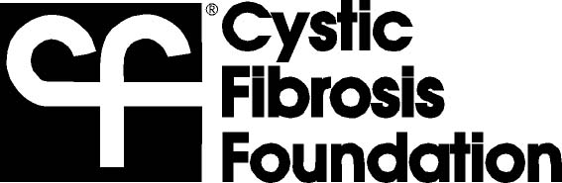
Please send payment and completed form to:
Cystic Fibrosis Foundation
5100 W. Kennedy Blvd., Suite 195
Tampa, FL 33609
(813) 374-9041
(813) 374-9045 Fax
Because of health risks to people with cystic fibrosis (CF), individuals with CF who have had a confirmed positive sputum culture for Burkholderia cepacia complex shall not attend events sponsored by the Cystic Fibrosis Foundation.
This policy is necessary because B. cepacia is contagious to individuals with CF. B. cepacia can be transmitted through casual contact or close proximity with infected individuals. B. cepacia infection in a person with CF can cause serious respiratory illness and, in some patients, may result in rapid decline in lung function, possibly leading to death. While this policy should reduce the risk of B. cepacia cross infection, there still might still be some individuals with B. cepacia in attendance. B. cepacia is not a known health risk to individuals without CF who are otherwise healthy.

The CF Foundation supports research to identify new treatments for B. cepacia. For alternative ways to participate and for more information regarding this policy, please contact the CF Foundation at (800) FIGHT-CF or visit www.cff.org. Consult your CF Foundation-accredited care center physician with medical questions.
A COPY OF THE OFFICIAL REGISTRATION (# CH956) AND FINANCIAL INFORMATION MAY BE OBTAINED FROM THE DIVISION OF CONSUMER SERVICES BY CALLING TOLL-FREE 1-800-435-7352 WITHIN THE STATE. REGISTRATION DOES NOT IMPLY ENDORSEMENT, APPROVAL OR RECOMMENDATION BY THE STATE.

To receive the maximum recognition for your participation during this event, we should receive this form no later than
September 13, 2011. .
Since 1955, the mission of the Cystic Fibrosis Foundation is to assure the development of the means to cure and control cystic fibrosis (CF) and to improve the quality of life for those with the disease. The CF Foundation tirelessly pursues its mission by supporting scientific research,

PARTNER WITH A RESULTS-DRIVEN ORGANIZATION

which is dedicated to the discovery and development of new therapies. At the same time, it funds and accredits a network of specialized treatment centers that provide state-of the-art care for people with CF. By applying the same principles that a “for-profit company” follows—efficiency, innovation and a results-driven approach—the CF Foundation is making a profound difference in the lives of those with CF.

The CF Foundation Is Efficient.
The Foundation is one of the most effective and efficient organizations of its kind. It has received a four-star rating for sound fiscal management from Charity Navigator, the largest independent charity evaluator in the United States, and is an accredited charity of the Better Business Bureau’s Wise Giving Alliance. .
What Is Cystic Fibrosis?
Cystic fibrosis is an inherited chronic disease that affects the lungs and digestive system of about 30,000 children and adults in the United States (70,000 worldwide). A defective gene and its protein product cause the body to produce unusually thick, sticky mucus that clogs the lungs and leads to life-threatening lung infections; and obstructs the pancreas and stops natural enzymes from helping the body break down and absorb food.

One in 31 Americans (more than 10 million people) is an unknowing, symptomless “carrier” of the defective CF gene.
Each time two carriers conceive, there is a 25 percent chance that they will have a child with CF.

The CF Foundation Is Innovative.
To quicken the pace of drug discovery and development, the Foundation has pioneered an innovative and highly effective business model. The Foundation has committed hundreds of millions of dollars in collaboration with the biotech industry to fuel the search for new treatments and a cure. The Foundation’s unique approach to drug discovery has yielded a therapeutics pipeline with more than 30 potential therapies in development for CF.
Virtually every approved CF drug available today was made possible because of Foundation support. Since the 1980s, the Foundation has played an integral role in the development of Pulmozyme®, TOBI®, azithromycin and hypertonic saline, essential drugs for the treatment of CF.

The CF Foundation Is Results-Driven.
The Cystic Fibrosis Foundation has fueled dramatic improvements in research and care that have significantly changed the prognosis for people with CF. When the CF Foundation began, few children lived to attend elementary school. Thanks to the research and care supported by the CF Foundation, the median age of survival for a person with CF is now 37 years. For the first time in the history of the disease, CF clinical trial participants are taking oral drugs aimed at treating the basic defect in CF (a faulty protein). If successful, these drugs could add decades of life for people with the disease.

The Foundation continues to be a strong and focused organization: 2009 was a banner year in terms of scientific and medical progress. As we look ahead, we are working more proactively and thinking more creatively than ever before. Although the outlook for a child born with CF today has improved tremendously over the years, it is not good enough. Your involvement and financial support are critical to our success. Working together, we can add tomorrows every day to the lives of all people with CF.

A Case for Support

The Cystic Fibrosis Foundation is an organization like no other. When you support the Foundation, you can… …

make a difference in the lives of people with this disease today. Dramatic improvements in the length and quality of life for people with CF are the direct result of the Foundation’s investments in quality care and research. Today, the median predicted age of survival is 37+ years — more than double what it was 25 years ago. …

join the team that is making tremendous strides toward a cure and control for cystic fibrosis, a life-threatening genetic disease that affects 30,000 children and adults in the United States. Each day, we are getting closer to finding a cure, but we need more people to support this effort to reach our goal. …

contribute to scientific advances that are making history. In 1989, Foundation-supported scientists discovered the cystic fibrosis gene— a monumental breakthrough on the road to a cure. The Foundation’s innovative approach to research has led to new investigational therapies that attack the disease at its core. If successful, these potential drugs could add decades of life for people with CF. …

feel good knowing you are backing a cause that truly needs your help. Cystic fibrosis is a rare disease. Although the Foundation is the primary sponsor of CF research, we receive no federal funding. The Foundation relies on the generosity of individual donors and corporations to fund its life-saving mission. We need your time, talent and support. …

rest assured your contributions will be used wisely. The Foundation has received a four-star rating for sound fiscal management from Charity Navigator, the largest independent charity evaluator in the United States, and is an accredited charity of the Better Business Bureau’s Wise Giving Alliance, meeting all of its Standards for Charitable Accountability. In 2009, nearly 90 cents of every dollar of Foundation revenue was invested in vital research, medical and education programs. …

become part of an organization that is making headlines. The Foundation has been recognized by Forbes, BusinessWeek, USA Today and Newsweek for its innovative approach to research. …

help fund medical research that will not only benefit cystic fibrosis but could benefit those who suffer from a range of other diseases as well, including chronic sinusitis, inflammatory bowel disease, Duchene muscular dystrophy and spinal muscular atrophy. …

have an impact locally. The Foundation funds and accredits a nationwide network of 110 CF care centers, which provide vital resources and support to patients and families in your community.

Local Care Centers:
All Children’s Hospital in St. Petersburg
Tampa General Hospital
Florida Pediatric Pulmonary Associates in Ft. Myers
Pediatric Pulmonology Division at USF

Please join us and help make “CF” stand for “Cure Found.” For more information, visit: www.cff.org.

